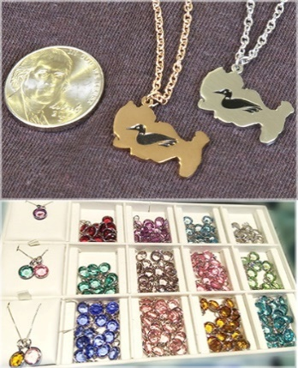
Jewelry Order Form

- Necklace comes with an 18" chain
- Earrings come with French wire; lever back is special order
- Rose Gold is rose gold plated over stainless steel
- Stainless steel is hypoallergenic

- Limited stock will be available at Merchandise Sales
- Rose gold or lever back order may take 4 weeks
Item |  |  |  |  |  | QTY | Price Each | Total Price
Stainless Steel Necklace with 18" stainless steel chain |  |  |  |  |  |  | 25.00
Stainless Steel Earrings with French wire |  |  |  |  |  |  | 25.00
Rose Gold Plated Necklace with rose gold plated 18" chain |  |  |  |  |  |  | 25.00
Rose Gold Plated Earrings with French wire |  |  |  |  |  |  | 25.00
Blue Charm |  |  |  |  |  |  | 5.00
Birthstone Charm (enter quantity) |  |  |  |  |  |  | 5.00
Jan |  | Feb |  | March
Apr |  | May |  | June
July |  | Aug |  | Sept
Oct |  | Nov |  | Dec
Special Order or Note: |  |  |  |  |  | Grand Total

 | Pay with check. Mail check and form to DLIA, PO Box 472, Pellston, MI 49769
 | Pay with credit card. An invoice will be sent to you by email.
 | Pick up order at Merchandise Sale. Specify which Sale date.
 | 6/16 |  | 7/4 |  | 7/21 |  | 8/11 |  | 9/1

 | Customer Information | Shipping if different and needed
Name
Address
Phone
email
Instructions to pay by credit card:
1. Complete the Order Form
2. Email form to Holly Gedert at merchandise@douglaslake.org (Questions: 231-537-3269)
3. An invoice for merchandise plus shipping and handling will be sent to you.
Version 2 - 5/24/18 hg

